TRADER WEBSITE GUIDELINE

1. REGISTRATION
2. EMAIL VERIFICATION
3. LOGIN
4. TRADER INTERFACE
5. VIEW / ADD / DELETE / UPDATE PRODUCT
6. CUSTOMER INVOICE
7. REPORTS
8. REGISTRATION LINK: The registration link is at the footer each page.

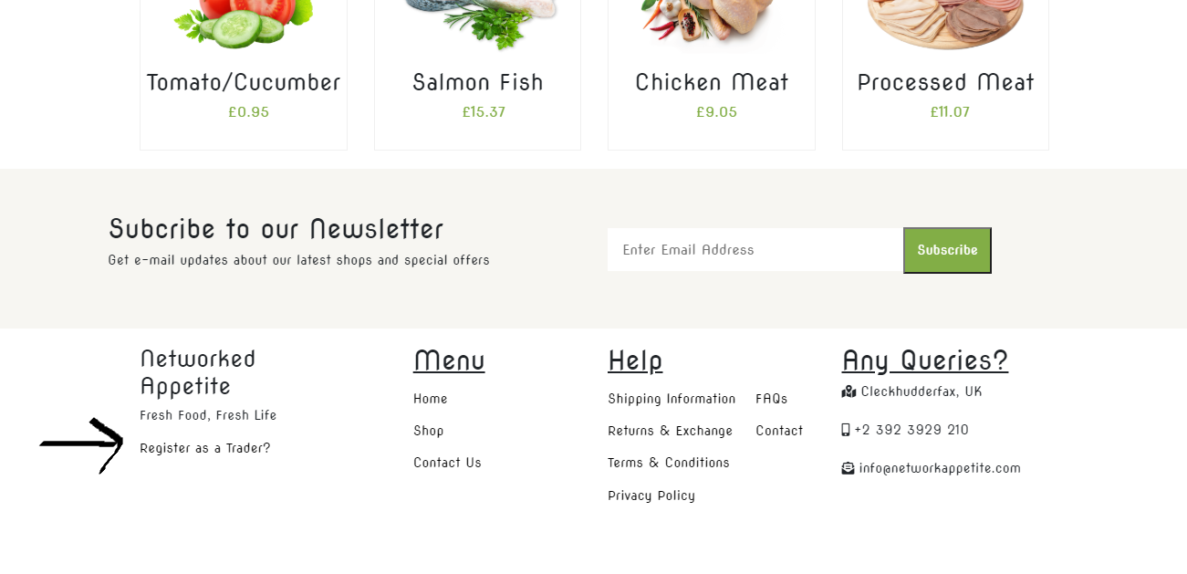

1. REGISTRATION PAGE: Trader can register their shop from this page.

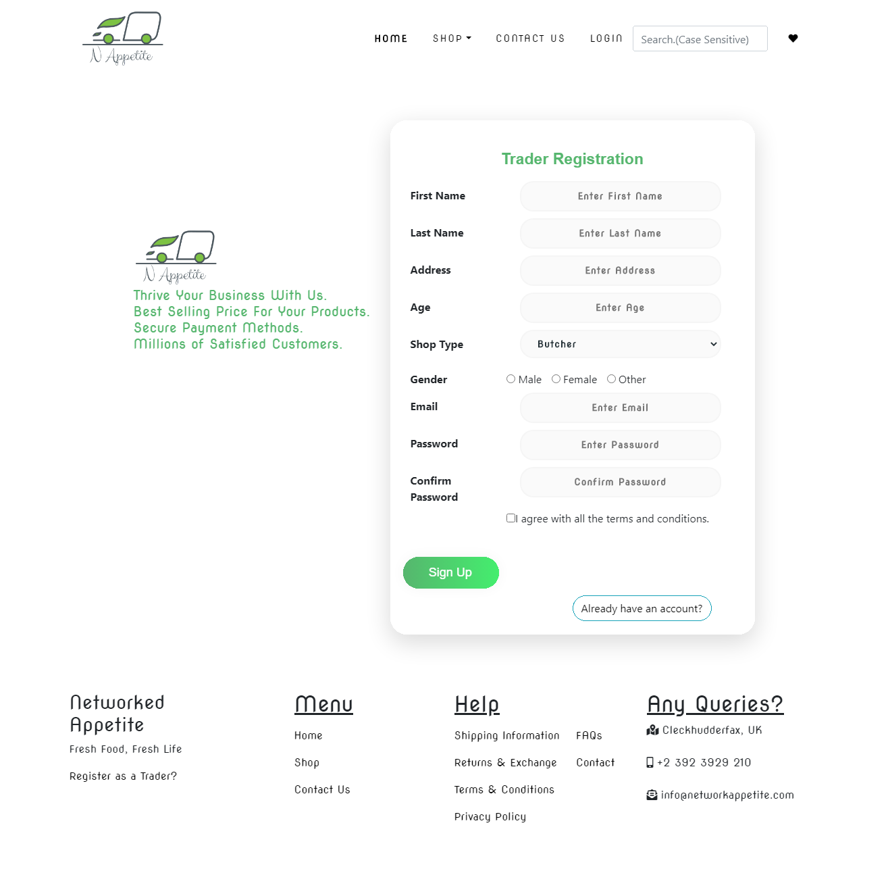

Trader will receive an email regarding verification link.

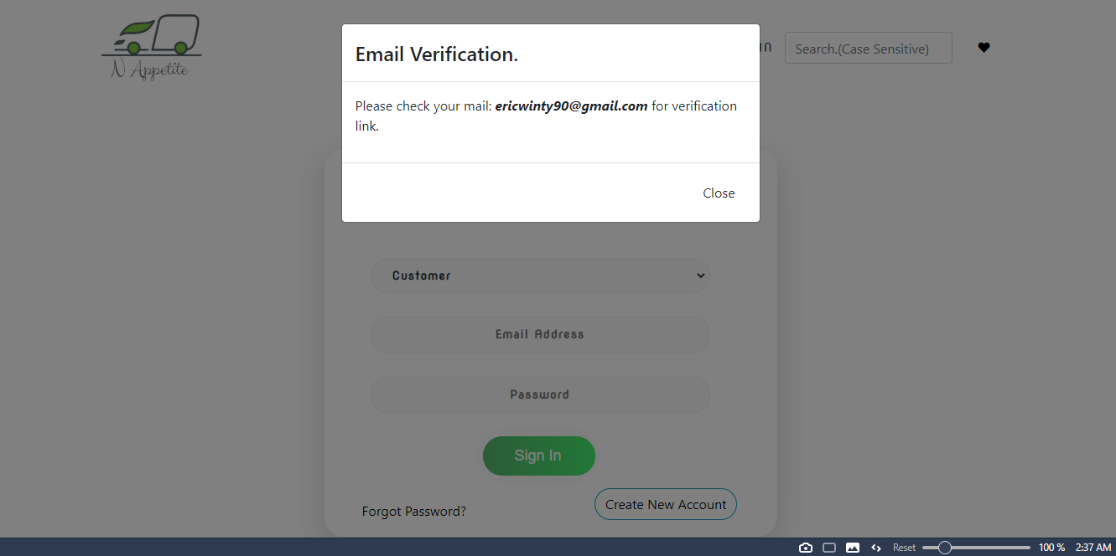

The email will be something like this. Click on Activate Account.

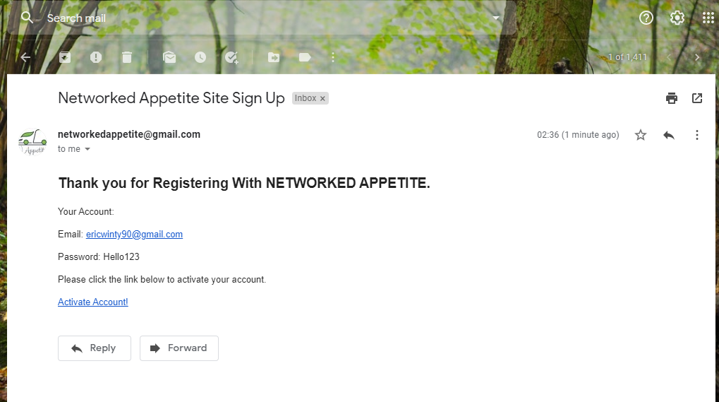

Clicking on the link will redirect to a page which will automatically verify the trader. Then the trader can login.

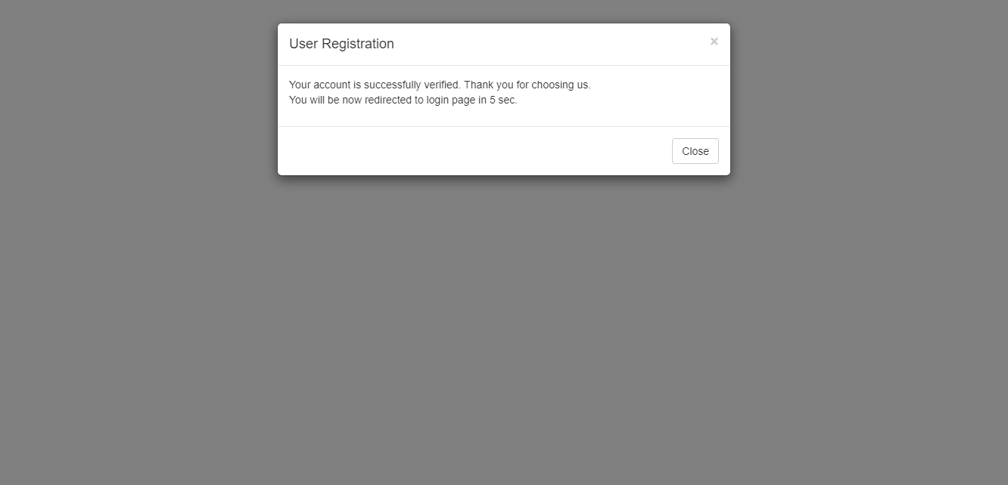

This is the login page. Trader can now login.

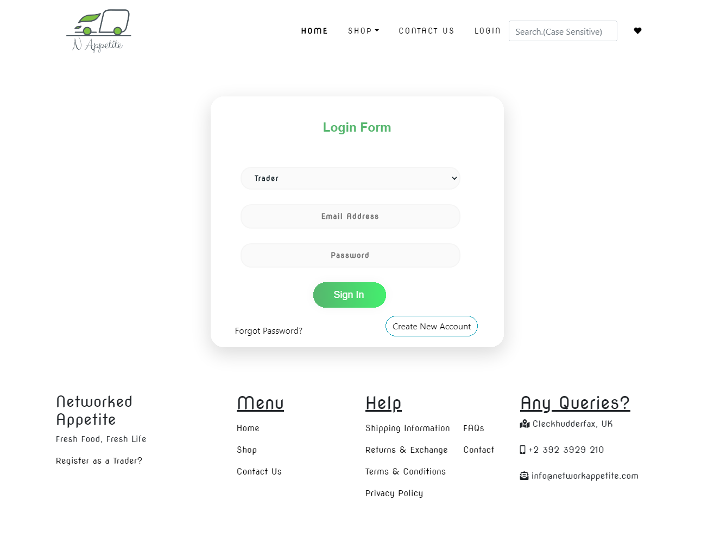

This is the trader interface part where products are shown.

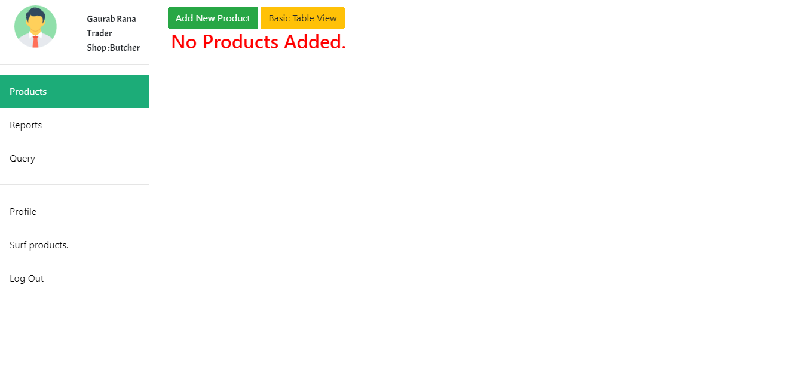

Trader can see their profile details on profile link on left side of the page.

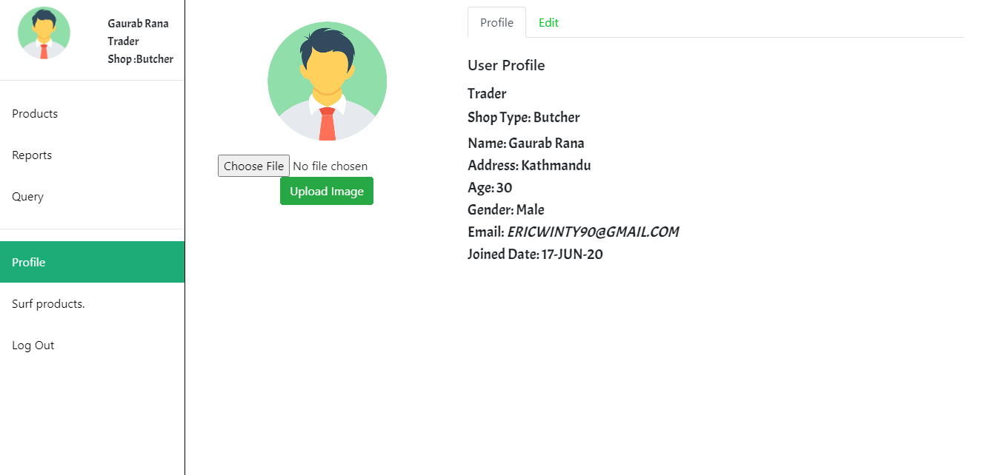

To update profile, click on edit tab.

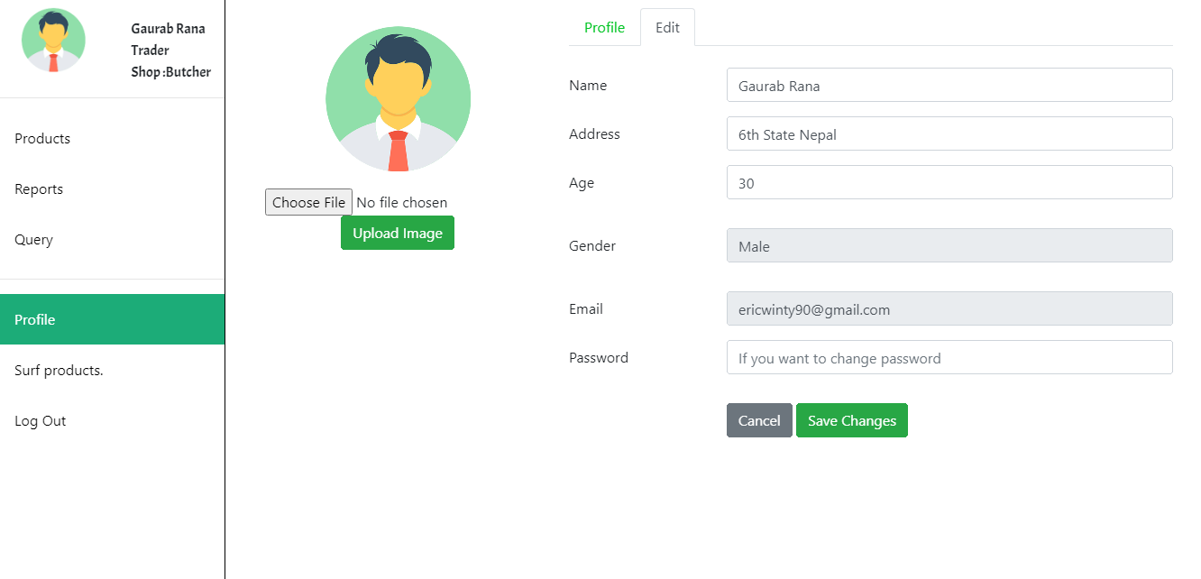

Trader can add / delete / update products.

To add click on add new product button.

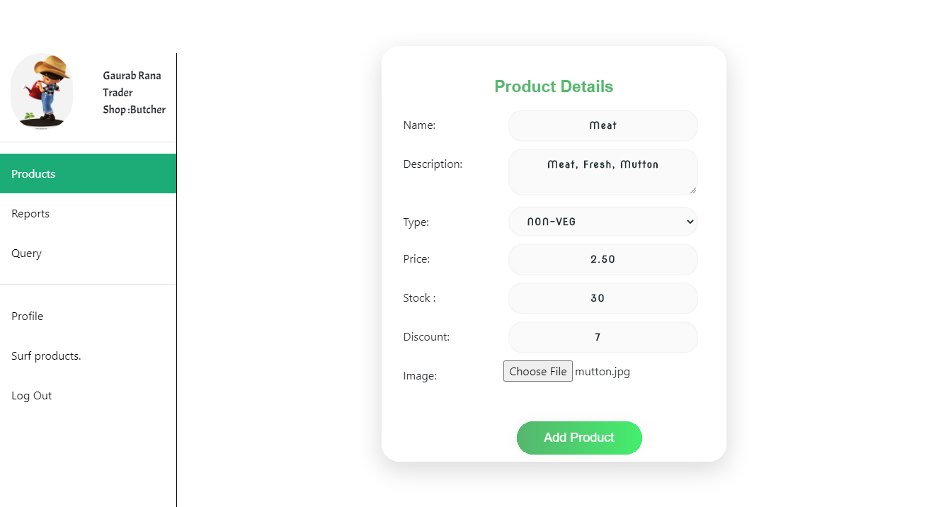

Adding some product and the detail will be shown like this.

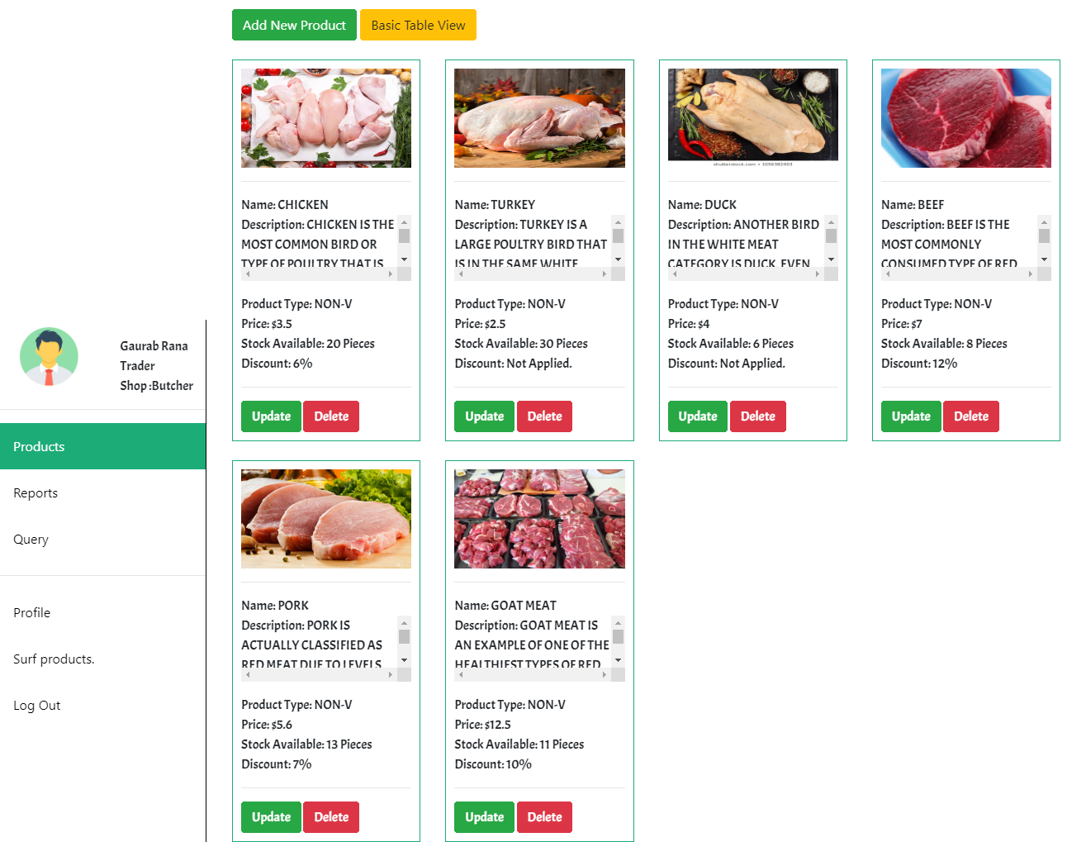

UPDATE PRODUCT: Clicking on update button will show something like this. And User Can Update Product.

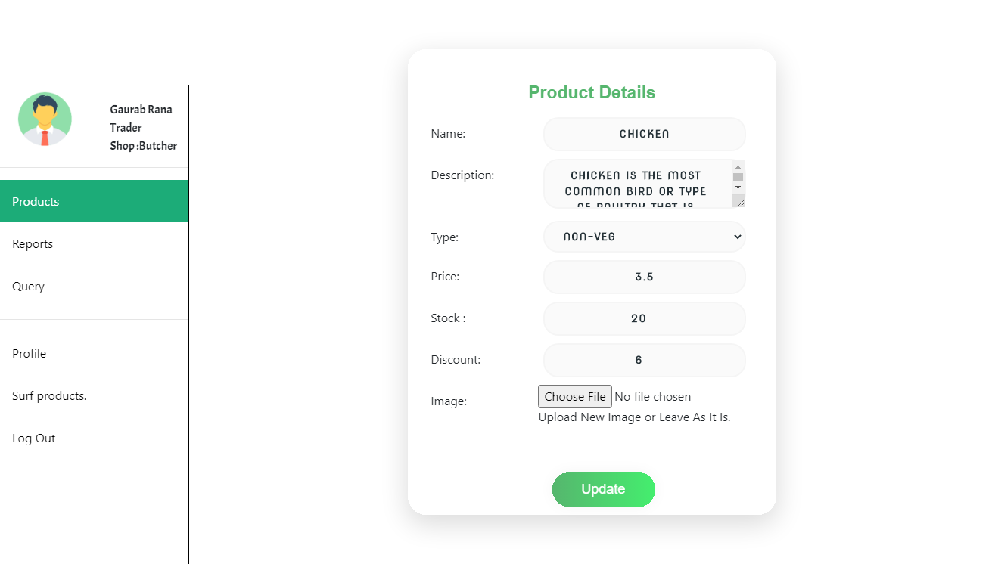

DELETE PRODUCT: Clicking on Delete Button Will delete the Product unless the product has been ordered and is in process of delivery.

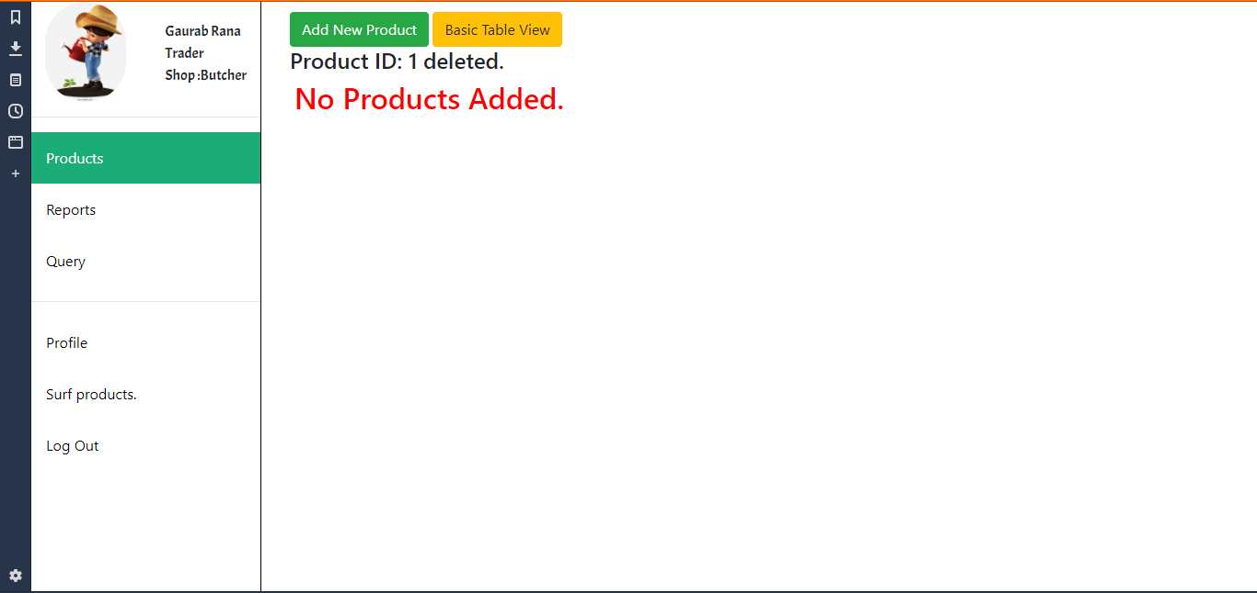

CUSTOMER INVOICE: Trader will get an invoice like this whenever a customer buy their product.

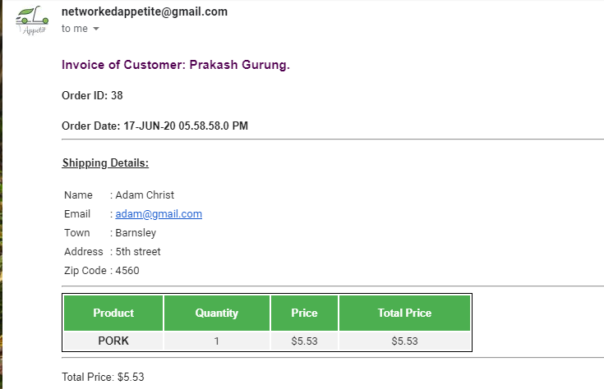

REPORTS: Clicking on the reports on left side of the page will redirected to oracle apex page where they can view their product. They have to login in order to view reports.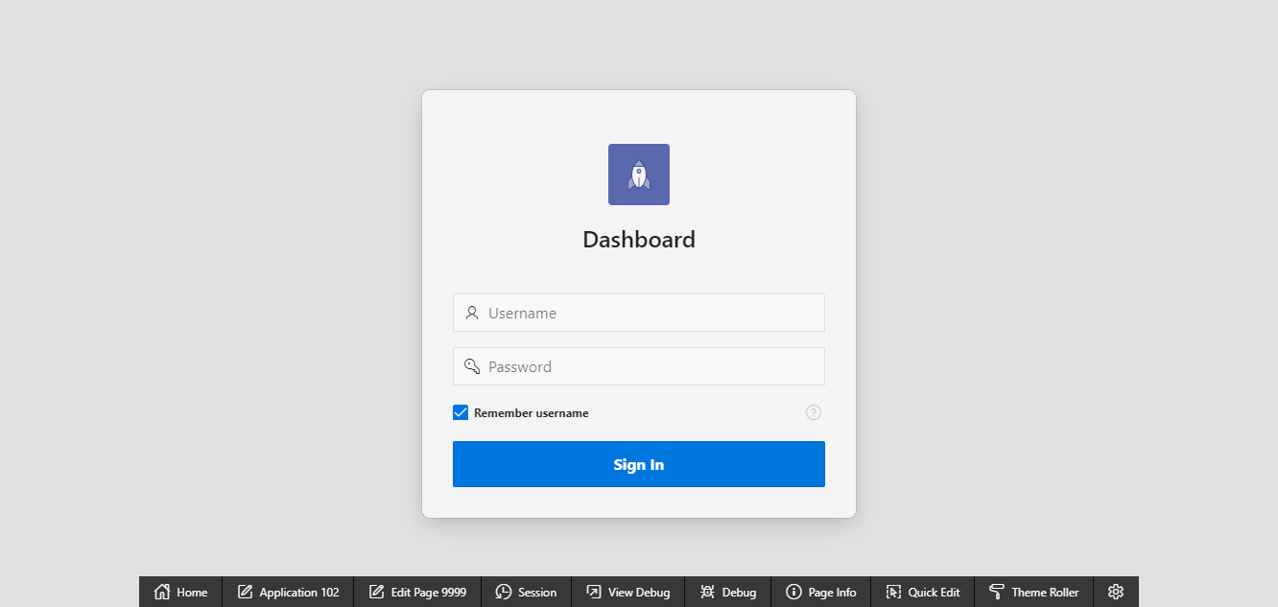

//END OF GUIDELINE